19.69: a) Solving for p as a function of V and T and integrating with respect to V,

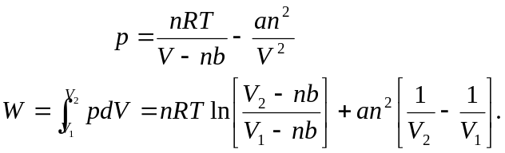
When 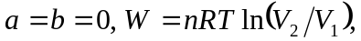as expected. b) Using the expression found in part (a),

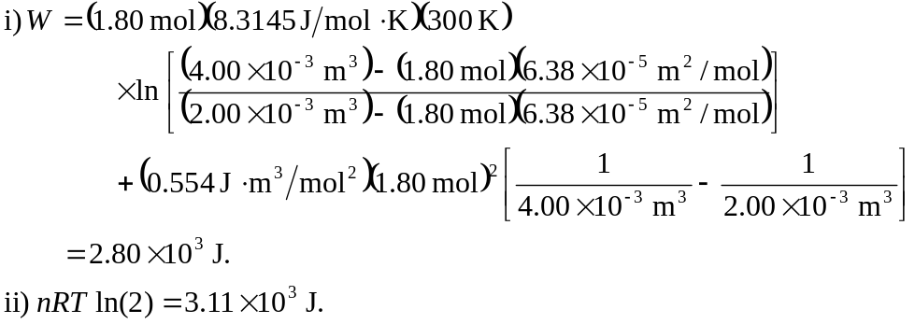
c) 300 J to two figures, larger for the ideal gas. For this case, the difference due to nonzero a is more than that due to nonzero b. The presence of a nonzero a indicates that the molecules are attracted to each other and so do not do as much work in the expansion.

